SIMATS ENGINEERING (SAVEETHA SCHOOL OF ENGINEERING) Department of Computer Science and Engineering
ASSESSMENT TOOL 2 – Industry Problem Solving Task
Course Code: | CSA06 | Course Title: | Design and Analysis of Algorithms
CO Assessed: | CO4: Articulation (BL4, BL5) | Assessment: | Assessment Tool 2 – Industry Problem Solving Task
Weightage: | 20% of CIA | Total Marks: | 100
CO4 Statement: | Solve optimization problems using dynamic programming and greedy strategies.
Student Name: | Ishwariya P | Reg. No.: | 192524445
Section / Batch: | 2025 | Date: | 24/8/26

Instructions to Students
• Answer the following question. Total Marks: 100.
• Carefully analyze the given questions.
• Explain in detail with sample code if needed.
• Clearly identify all key issues.
• Provide a thorough analysis with validated results and performance evaluation.

Question Type | Focus Area | Questions
Industry Problem  Solving Task | Focus on Solving optimization problems using dynamic programming and greedy strategies | Q1

SECTION A – Industry Problem Solving Task
Code of Conduct
I _Ishwariya P(192524445)_________________________ (Name / Reg No) certify that this submission is my original work and that I have adhered to the guidelines specified for this assessment. I understand that any violation of academic integrity rules will result in disciplinary action.
Signature of the Student: _________________________

RUBRICS FOR CALCULATION
Industry Problem Solving Task
Criteria | Weightage | Level 4 – Exemplary | Level 3 –  Proficient | Level 2 –  Developing | Level 1 –  Beginning
Understanding of Industry Problem | 20% | Comprehensive  understanding of  real-world problem and constraints | Good  understanding with minor gaps in  requirements | Basic  understanding;  some  requirements  unclear | Poor  understanding;  misinterprets  problem context
Application of  Engineering  Concepts | 25% | Applies advanced  and relevant concepts effectively to solve the problem | Applies  appropriate  concepts with  minor errors | Limited  application of  concepts | Incorrect or no  application of  concepts
Solution Design | 25% | Innovative, practical, and feasible solution aligned with industry standards | Logical and  feasible solution  with minor gaps | Basic solution  with limited  feasibility | Unclear or  impractical  solution
Use of Tools | 15% | Effective use of  modern tools,  technologies, and real data | Appropriate use of tools with correct implementation | Limited or  inconsistent use of tools | Minimal or  incorrect use of  tools
Analysis | 10% | Thorough analysis with validated results and performance  evaluation | Good analysis with reasonable  validation | Basic analysis  with limited  validation | Poor or no  analysis
Professionalism | 5% | Highly professional, well-documented,  and clearly presented work | Good  documentation and presentation | Basic  documentation  with some gaps | Poor  documentation  and presentation

Marks Evaluation:
Criteria | Wt. | Level 4 –  Exemplary | Level 3 –  Proficient | Level 2 –  Developing | Level 1 –  Beginning
Understanding of Industry Problem | 20%
Application of Engineering Concepts | 25%
Solution Design | 25%
Use of Tools | 15%
Analysis | 10%
Professionalism | 5%
Total Marks (100):

Faculty In-charge | Course Coordinator | Head of Department
Name: | Name: | Name:
Signature: _______________ | Signature: _______________ | Signature: _______________
Date: ___________________ | Date: ___________________ | Date: ___________________

Aim

To optimize traffic signal green-light timings using Dynamic Programming by minimizing the total waiting/delay time based on traffic density, maximum green time, and vehicle clearance rate.

Algorithm
- Read the number of intersections and traffic density at each intersection.
- Read the maximum allowable green-light time and vehicle clearance rate per unit time.
- Create a DP array where dp[i] stores the minimum total delay for the first i intersections.
- For each intersection:
  - Try every possible green time from 1 to max_green_time.
  - Calculate the traffic cleared.
  - Calculate the remaining traffic.
  - Calculate the current delay.
  - Add the current delay to the previous optimal value.
- Store the minimum cost in dp[i].
- Return dp[n] as the minimum total waiting time.
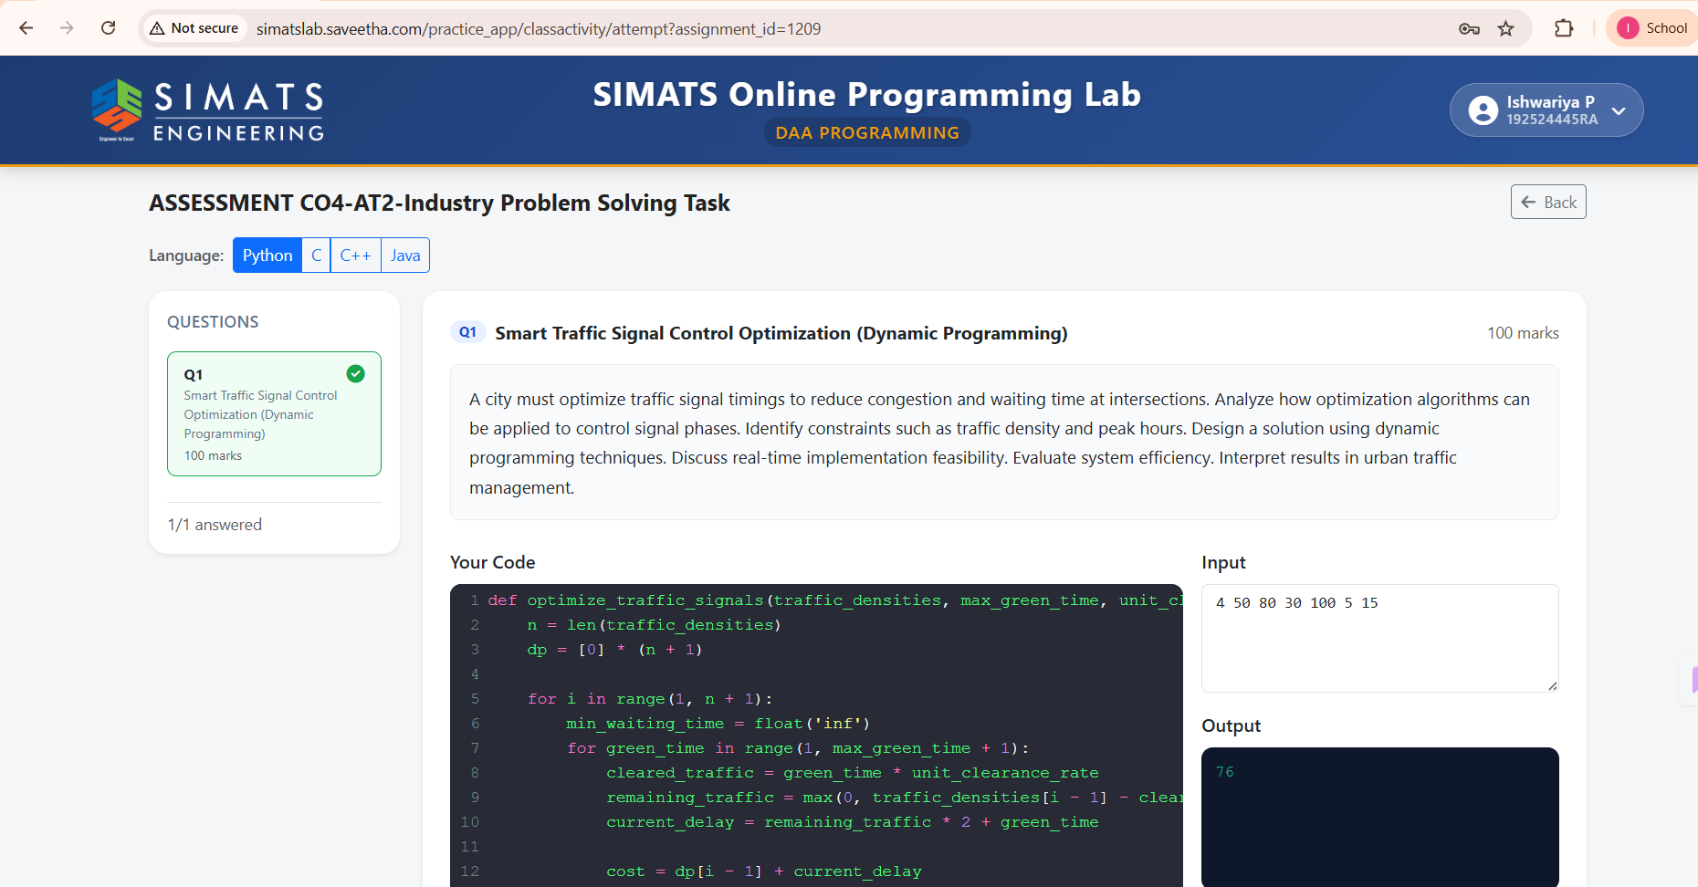

Python Code

def optimize_traffic_signals(traffic_densities, max_green_time,
unit_clearance_rate):
n = len(traffic_densities)
dp = [0] * (n + 1)

for i in range(1, n + 1):
min_waiting_time = float('inf')

for green_time in range(1, max_green_time + 1):
cleared_traffic = green_time * unit_clearance_rate
remaining_traffic = max(
0, traffic_densities[i - 1] - cleared_traffic
)

current_delay = remaining_traffic * 2 + green_time
cost = dp[i - 1] + current_delay

min_waiting_time = min(min_waiting_time, cost)

dp[i] = min_waiting_time

return dp[n]

data = list(map(int, input().split()))

n = data[0]
traffic_densities = data[1:n + 1]
max_green_time = data[n + 1]
unit_clearance_rate = data[n + 2]

result = optimize_traffic_signals(
traffic_densities,
max_green_time,
unit_clearance_rate
)

print(result)

Result

For the given input:
4 50 80 30 100 5 15
The program produces:
76
Thus, the minimum optimized total traffic delay is 76 units.

